Current voltage power sensor

# **Adafruit INA260**

Features

• Precision Integrated Shunt Resistor:

– Current Sense Resistance: 2 mΩ

– Tolerance Equivalent to 0.1%

– 15-A Continuous From –40°C to +85°C

– 10 ppm/°C Temperature Coefficient (0°C to +125°C )

• Senses Bus Voltages From 0 V to 36 V

• High-Side or Low-Side Sensing

• Reports Current, Voltage, and Power

• High Accuracy: – 0.15% System Gain Error (Maximum)

– 5-mA Offset (Maximum)

• Configurable Averaging Options

• 16 Programmable Addresses

• Operates From a 2.7-V to 5.5-V Power Supply

• 16-Pin, TSSOP Package

Applications

• Test Equipment

• Servers

• Telecom Equipment

• Computing

• Power Management

• Battery Chargers

• Power Supplies .

[1] “Adafruit INA260 Current + Voltage + Power Sensor Breakout,” *Adafruit Learning System*. https://learn.adafruit.com/adafruit-ina260-current-voltage-power-sensor-breakout/overview (accessed Jan. 25, 2021).

[2] “Adafruit INA260 Current + Voltage + Power Sensor Breakout,” *Adafruit Learning System*. https://learn.adafruit.com/adafruit-ina260-current-voltage-power-sensor-breakout/arduino (accessed Jan. 25, 2021).

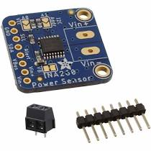

Adafruit INA260[1]

Description

INA260 can measure up to 3 amps but it can measure low current such as 1 milli amps .it use I^2C bus ,SCL which is a clock and SDA data pin and Vcc can operate at 5 volt .

It is a high side current monitor which can handle up to 0 to 26 volt ,measure the current through a shunt resistor .the voltage and calculated power records over I^2C.The chip runs across supply voltage of 2.7-5.5 volt.

Practical work

Connection

To measure the current , bus voltage and power we have connect ina260 with adruino mega 2560 , and for the load we use a led light followed by the resistance . we have followed the below figure connection .The connect procedure are followed as

. If you are running a Feather (3.3V), connect Feather 3V to board VIN

. If you are running a 5V Arduino (Uno, etc.), connect Arduino 5Vto board VIN

. Connect Feather or Arduino GND to board GND

. Connect Feather or Arduino SCL to board SCL

. Connect Feather or Arduino SDA to board SDA

. Connect Vin+ to supply for high side current sensing or to load ground for low side sensing.

. Connect Vin- to load for high side current sensing or to board ground for low side sensing

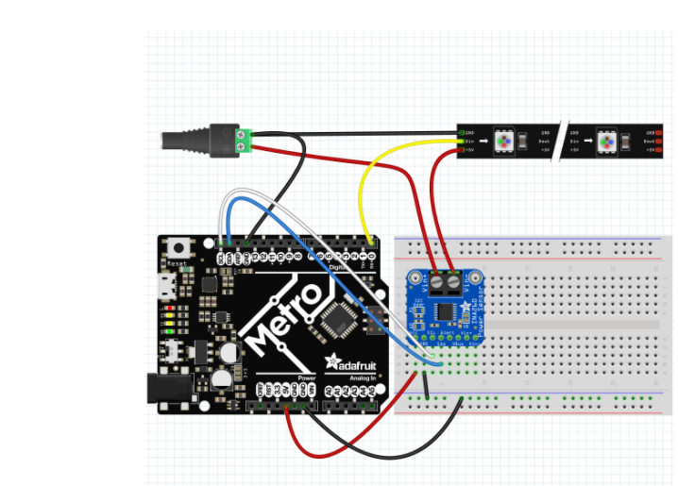

The connection of ina260 with adafruit metro [2]

In our project we have connect to Arduino mega2560 with ina260.the connection ,output and the script in the ARDUINO is given below

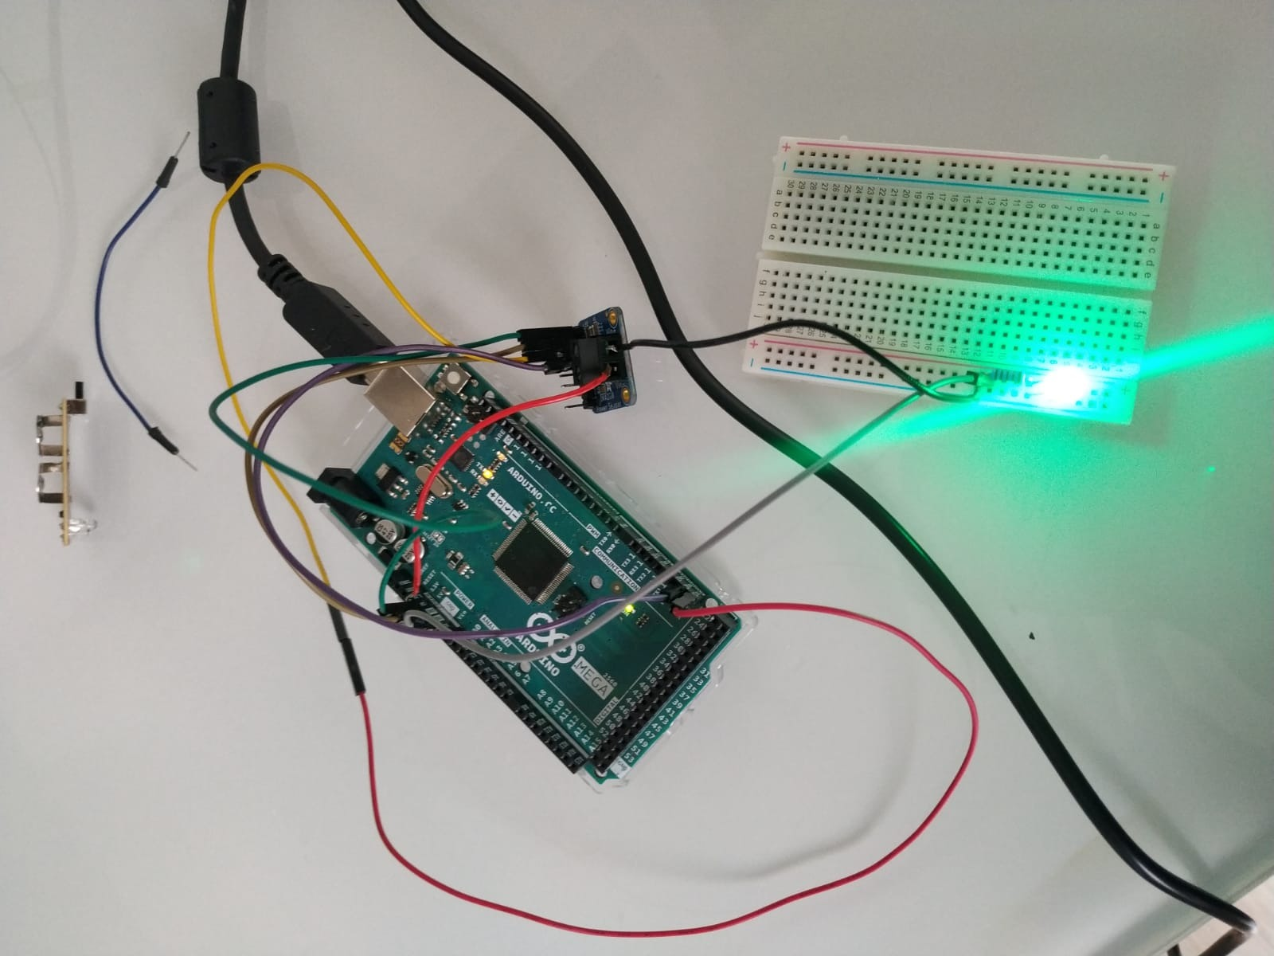

Connect with mea2560 with ina260 .

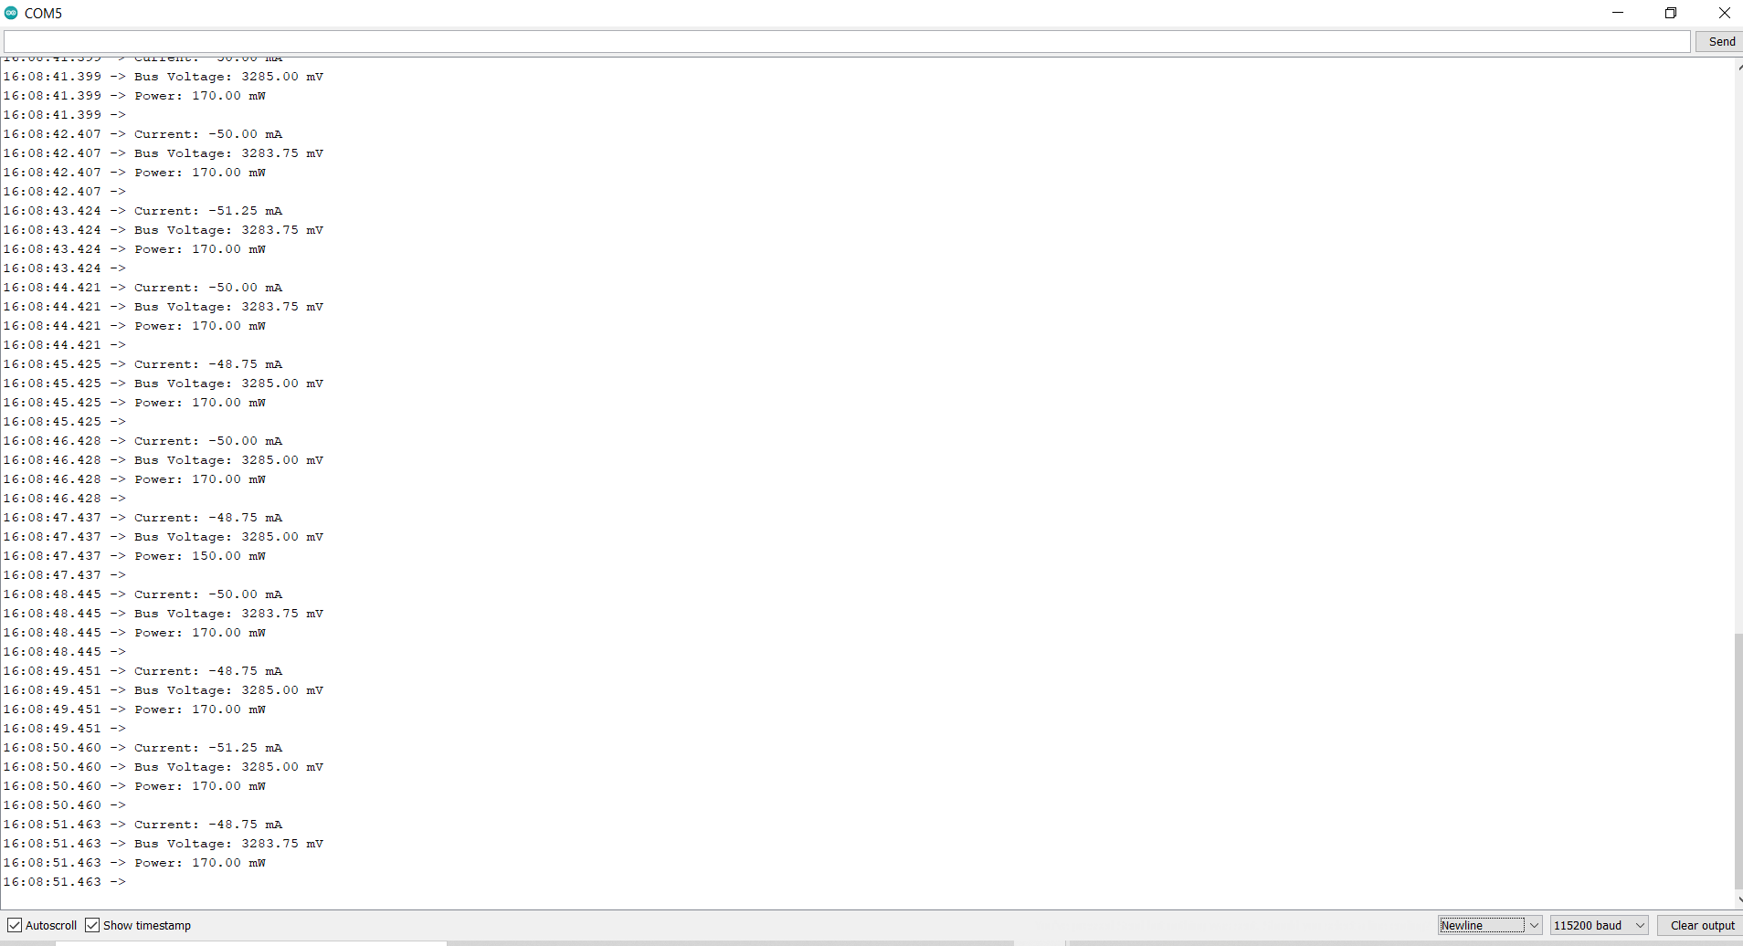

Screen short of the Output data .

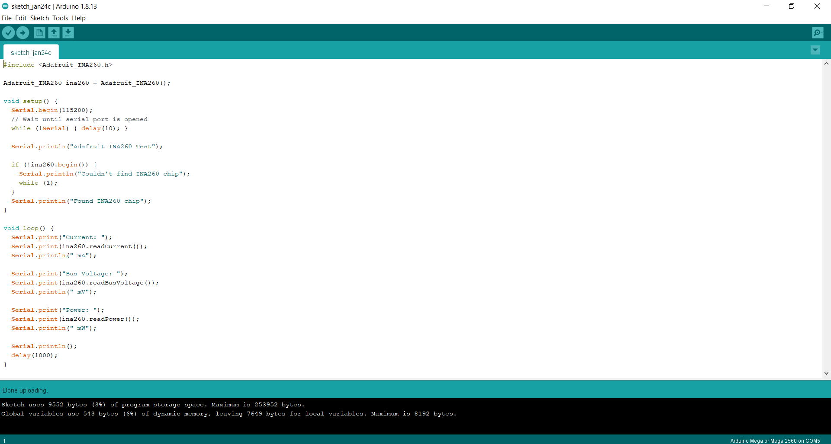

Screen short of the script .

From the above practical work we can conclude that to monito the current ,bus volta and the power we can use this sensor on the charging port .

ANEMOMETER PRACTICAL .

as the data collection of the wind speed from the anemometer are present in ALFRESCO ,we have tried to contact with the manufacturer company of the wind sensor to ask the other procedure to collect the data from the wind sensor directly ,they had reply to connect the following way,

Red wire = +12V

Blue wire = 0V

Connect the sensor to a serial port:

Blue = Ref (terminal 5 of a 9pts SubD socket)

Yellow = Tx (terminal 2 of a SubD 9pts socket)

. With help of the software name “ TERMITE” we can read the data ASCII data, with the option of 4800 Bands, 8 Bits, 1 Stop bit, with no parity. The link is : <https://www.compuphase.com/software/termite-3.4.exe>.

CHARGE CONTROLLER

The charge controller constantly monitor the voltage of the storage cell. In the case of 24 volt battery cell if the storage cross above the limit it will disconnect the circuit to prevent from over flow .

The basic working principle of charge controller

1. Converting AC (3 phase) to 2 phase D.C by bridge rectifier basically.
2. Voltage regulation to charging the battery.
3. Disconnecting the battery when it get fully charge and connecting dump load to break down the circuit .(dump load low value resistor across the output voltage of the turbine to break the ckt) .

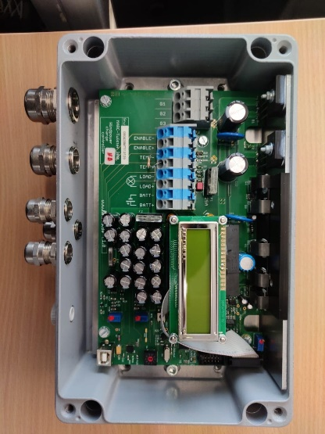

Charge controller provide by venco twister.

Greetings YouTubers Here is the guy with the Swiss accent

It seems that LoRa and IOT are somehow connected

and both are currently hyped very much.

Today I try to put things a little in order, show you

the basic principles of LoRa, it's pluses and minuses

and also show you my own LoRa gateway and a LoRa client.

And of course, I will send the first message to the things Network.

A lot of stuff. So, buckle up the journey starts.

LoRa is a low-power wide area network standard. Also called LPWAN.

This term consists of three parts.

One, low power. Two, wide area. And three, network.

let's start with network. The difference between a normal small device and an IOT device

is it's capability to connect to the internet.

And because we expect millions of them, we need a network to connect all of them

This network has to be based on standards because the network itself

and the IOT devices will not be built by the same company.

Best is always an international standard accepted by everybody. The next part is wide area.

Our ESP8266 devices can connect to our Wi-Fi network which is part of a LAN or local area network .

We all know that it's reach is limited to a few meters around our access points.

Wide area networks need to bridge much bigger distances.

This is necessary for IOT devices, because we want to use them everywhere.

The real old guys amongst us might remember AM radio stations.

We were able to receive AM even in the middle of nowhere. Far away from the station.

This was a really wide area. But these transmitters were huge.

Usually they were emitting kilowatts of energy.

So it seems to be quite easy to bridge big distances using high power.

But now we come to the third word. Low power.

If we want to work on batteries we do not have lots of power for transmission.

And here we see the dilemma. We want kilometers of reach, but have no power to spend.

Fortunately physics gives us a third parameter to ease this dilemma a bit.

It is called bandwidth. The physical laws say that if we want to create radio connections for a certain distance,

we can either increase transmission power or decrease the bandwidth of the channel.

But why should we bother about bandwidth?

Because bandwidth and maximum capacity of a channel are directly related.

The smaller the bandwidth, the lower the capacity of our channel.

I still remember the old days of Morse, where a good operator was able to transmit 2 characters/sec.

Which is a little less than 20 bits/sec.

Today our wireless LANs are capable of transferring millions of characters per second. And they are still always too slow.

To visualize the relation between bandwidth and range, we can use this chart.

On the x axis we have the range and on the y-axis the bandwidth.

let's now look at some of the well-known technologies and where they fit.

Wi-Fi has a high bandwidth but only a low reach; and we know from our esp8266 it is quite power-hungry,

not in the kilowatts as the old radio stations, but it easily needs a quarter of a Watt during transmission.

And if we go up into the new faster standards the power hunger increases.

And you know that the reach of 5 gigahertz links is shorter than the ones of 2.4 gigahertz links.

The next technology is mobile Internet on our smartphones.

The reach here is a few hundred meters up to a few kilometers in rural areas.

But also here you do not get fast 4G coverage if you are in the middle of nowhere,

because the next antenna tower is probably a few kilometers away.

And we all know that the battery life of our smartphones is not great at all.

Because this technology needs quite some power.

The next technology is Bluetooth this technology

runs well on small batteries as we know

from many gadgets but unfortunately it

reaches only a few meters so all of

these technologies do not fulfill the

needs of our IOT devices which was low

power and wide area I think you know now

what will come LoRa it has its own

space long range but because of power

limitations also low in reality

extremely low bandwidth and this

bandwidth is not only limited by the law

of physics no it is even more limited by

human laws as we will see later on so we

know now where LoRa fits to make it

very clear it is absolutely not

comparable with Wi-Fi and not at all a

replacement of this technology it is

much closer to the mobile internet

standards where also low-power variants

are in development but it has its space

with sensor networks if these sensors do

not transmit a lot of data for telemetry

in Formula One races for example this

technology would not be suitable because

of the number of readings required for

humidity of your plants it is perfect

because soil humidity usually does not

change in second or if you monitor the

occupation of a parking lot you also

might not detect too many changes a day

in order to understand the range better

we have to deal with a quite complex

topic the link budget what is this the

link budget and why it is so important

the link budget is as every other budget

something you have at the beginning and

which you spend over time if your budget

is used up you cannot spend more at

least this is what we learned when we

were young the link budget also has to

do with a link or the connection between

the sender and the receiver it is filled

up by the transmission power of the

sender and the sensitivity of the

receiver and it is calculated in decibel

or dB it is also frequency-dependent the

link budget is deducted by all sorts of

obstacles between the sender and the

receiver like distance cables walls

trees and so on if the link budget is

used up the receiver will only create

some noise and we will not get any

usable signal so what is the link budget

for LoRa compared with other

technologies like LTE or 4G LoRa has

according its inventor Semtech a link

budget of 154 dB which is much higher

than the mobile internet with only 130 dB

even if the radiated power is much

higher than with LoRa but what does

this mean is this an important

difference fortunately we find so called

radio link budget calculators on the

intimate let's do some calculations to

understand the topic better first let's

assume we have a line of sight

connection between the sender and the

receiver and everything is perfect as we

know our LTE budget is 130 dB so let's

check the biggest distance we can

communicate we set everything to 0 and

the distance to 100 kilometers and we

get minus 131.5 dB which is already

more than the 130 available so LTE even

in ideal conditions does not reach 100

kilometers 80 kilometers would be ok now

we check LoRa with a link budget of 154 dB

at 1,000 kilometers it is still

below the 154 dB and that 1,300

kilometers it is close to the 154 dB I

think you get the point as I said this

is all theoretical if we connect our

antennas to the sender and receiver and

we assume that we have 10 meters of

cable in total we lose about eight dB

the maximum distance is now reduced to

only 500 kilometers so 10 meters of

cable is equivalent to 800 kilometers in

free air and we did not use thin tables

like this pigtailed we used the normal

rg58 cable next we have to spend part of

our budget for all obstacles between the

sender and the receiver like walls or

trees the thicker and the more

conductive the obstacle the more budget

it requests and sometimes we even do not

have a line of sight connection and we

have to work with reflected signals

which reduces the link budget extremely

luckily we can also increase the budget

we can add an amplifier between the

sender and the antenna or we can use a

different kind of antenna with some gain

I will not cover this topic here but at

the end human law allows us only a

certain power emitted by the antenna

because we use a free band I shortly

mentioned 868 megahertz before this is

the frequency used by LoRa in Europe if

we ask Google we see that each region

uses different frequencies this is why

you have to pay attention when you buy a

LoRa device

they all have their band marked on the

back and because my Chinese supplier

sent me a wrong device I even have now

one for 915 megahertz to show you all

these frequencies have something in

common they are free bands and we do not

need to apply for a license or pay a

monthly fee to use it which i think is

very good but it comes with a handicap

the allowed power is only 25 milli watts

in Europe and a little more in the US

which is really not a lot even my small

amateur radio rig has 5 watt output

power we learned that the budget of

LoRa is much bigger than of LTE why is

this is LoRa really the better

technology or did its inventors even

create a miracle no LoRa is not at all

a miracle it complies with all physical

laws its high budget is mainly achieved

by a very narrow bandwidth so how big or

small is the throughput of such a LoRa

connection the rated capacity ranges

from 250 bits per second to 250 kilobits

per second which is rather low compared

with the mega bits of LTE but

unfortunately this is not the whole

truth as we will see later on one

important thing at the end the lower

standard is supported by a big alliance

of companies called the LoRa Alliance

which is important for its future up

till now we just covered the

transmission technology between the IOT

device and something the next question

is how can we connect our other devices

or applications to these devices here

comes the network into play it is called

LoRaWAN the LoRaWAN band consists of

distributed gateways or concentrators

which are connected to the Internet and

it consists of an

infrastructure which is capable to

transmit the IOT messages to our

applications here we have an overview

over the whole infrastructure many

devices connects to one gateway many

gateways are connected to the broker

infrastructure and many applications are

also connected to the same brokers and

here we see two different approaches the

commercial and the community approach in

many places telecom companies started to

deploy LoRa networks as with cellular

phones you can buy a contract and use

this infrastructure you just have to

connect your device to the available

networks here you see a press release

from the Netherlands and also a price

plan from Swisscom sig Fox is only

providing IOT communication but they you

do not use LoRa they use a slightly

different protocol between the IOT

devices and the network the community

approach is led by The Things Network

abbreviated TTN you find a link in the

description these guys built an

infrastructure to transfer the messages

between the gateways and your

application but they need of course many

gateways all over the world and because

of that they are glad if people like me

build such a gateway and deploy it they

provide a map of all available gateways

and you can check here if one is close

to you if so you can connect your device

through this gateway and the TTN network

to your application free of charge of

course great unfortunately there was no

gateway where I live so I had to build

my own here it is it consists of a

concentrated PCB in my case a IC 888

from I'm stand a raspberry 2 the

concentrator has eight RF channels so it

can support up to eight IOT devices in

parallel which is not alot

if we read the projected numbers of

millions of IOT devices so what to do if

we would agree that each device would

only use one channel let's say for fifty

percent of the time we could already

support 16 devices and if each device

only would use the channel by one

percent of the time we could already

support 800 devices just with my gateway

and this is exactly the concept this is

why I told you before that the bandwidth

will be reduced even more and this

concept is also in line with the law

which allows only a one percent maximum

usage of these frequencies by one device

so you can divide the 250 bits per

second by a factor of 100 which ends up

in 2.5 bits per second in the worst case

and now we are slower than morse and we

are not finished with reducing capacity

you remember your walkie-talkies what

was the rule there yes only one should

speak at one time otherwise nobody got

anything and because LoRa uses the same

channel for both communication

directions this applies here as well to

preserve the valuable capacity and

because we want to use this network

mainly for sensors LoRa favors the

direction from the sensors to the

Gateway and limit the traffic in the

other direction also that will be a

topic of future videos so I have now a

gateway in my area and I only need one

additional part a sensor node all sensor

nodes consist of at least two

components a microprocessor and a

communication module you can use your

microprocessor of choice and connect it

with the communication module which

complies with the LoRa standard there

are a few out there mainly the RF m95

and the SX 1276

as already mentioned these modules

usually exist in three different

versions for 433 868 and 915 megahertz

by the way they are not as cheap as

other RF modules this is probably

because the LoRa technology belongs to

only one company Semtech for my first

tests I use a Dragino shield and an

Arduino Uno also this device will be

covered in one of the next episodes but

now let's check if the whole thing works

the Arduino should be capable to

transfer a message so first let's check

in the air yes the spectrum analyzer

receives some traffic on frequencies

between 868 and 869 megahertz so the

sensor device works and the concentrator

you should get it because we still have

lots of link budget left the distance is

only a few centimeters and there are no

major obstacles between the two devices

so let's check on the console of TTN yes

we see the message and it is high so

summarized LoRa is a new transmission

standard between distributed devices and

distributed gateways it has an extremely

low channel capacity a very low power

consumption and therefore a very high

link budget which makes it ideal for

low-power sensors distributed

everywhere all so far from the next

gateway there are two different

approaches for the network a commercial

and the community approach the community

approach is based on privately built and

operated gateways and an infrastructure

which transfers the messages from the

Gateway to your application this was the

first introduction the next episodes will

cover the build and connection of a

gateway as well as the build of a client

some range tests and so on stay tuned I

hope this video was useful or

at least interesting for you if true

then like bye

you

English

AllRecently SearchedRaspberry PiElectronic componentsWirelessRelatedFrom Andreas SpiessRecently uploadedWatched